

Project Management Toolkit

Version: 1.0

Last Updated: 23rd November- Formally agreed by the Transformation Programme Sub-Committee

Contents

1. Introduction 3
1.1 Definition of a Project 3
1.2 Why have a Project Management framework? 3

2. Project Management Framework 4
2.1 Stage 1: Identify Project 4
2.1.1 Create the project board 4
2.1.2 Create an Outline Business Case 5
2.2 Stage 2: Plan Project 5
2.2.1 Product Based Planning 6
2.2.2 Stakeholder Management 7
2.3 Stage 3: Deliver the Project 8
2.3.1 Managing Product Delivery 8
2.3.2 Reporting Progress 9
2.3.3 Issues 9
2.3.4 Risks 9
2.4 Stage 4: Close Project 10

3. Document Version Control 11

Appendix – Project Templates 112

1. Introduction
The purpose of this document is to outline the framework within East Cambridgeshire District Council for identifying, planning, authorising and reporting projects.
This is not intended to be a comprehensive guide to project management.

1.1 Definition of a Project
A project is temporary in nature and should have a beginning, middle and (importantly) an end.

PRINCE2 defines a project as:
'A management environment that is created for the purpose of delivering one or more business products according to a specified business case'.

There are many other similar definitions of what constitutes a project. An even more basic definition is:
- Unique
- Time-limited
- Leading to change

1.2 Why have a Project Management framework?
The environment within local government is constantly changing. Increasing expectations mean that there are more projects on the go at the Council than at any other time. The ability to consistently deliver projects is increasingly becoming a measure of our effectiveness.

The Council spends a significant amount on project related activity, therefore it is vital that this investment and effort delivers real community and business benefits.
A regional survey carried out in May 2007 indicated that 30% of projects were cancelled before completion and that 88% of projects exceeded deadline, budget or both. Some of the common reasons for project failure include:
- Lack of a good business case;
- Failure to communicate with the right people;
- Lack of clearly defined deliverables;
- Inaccurate estimating of the time and effort;
- Lack of visible senior management commitment; and
- Lack of appropriate skills or insufficient resources.

Most of the time these issues can be avoided by planning upfront. The project management framework has been set up to ensure projects:
- Are controlled and follow good practice without unnecessary bureaucracy
- Do not take place unless they have a valid business case that is in the Council’s interest
- Work together towards the corporate vision of the future
- Make best use of resources
- Don’t just deliver outputs but outcomes

2. Project Management Framework
Projects run at East Cambridgeshire District Council involve 4 basic stages:

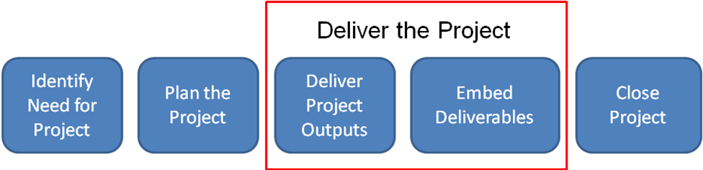

The following sections describe the 4 basic stages.

2.1 Stage 1: Identify the Need for the Project
This first stage is aimed at ensuring the project fits is in line with the Council’s ambitions and that the project concept is sound, worth pursuing and deserves investment in money and time above other proposed projects.

2.1.1 Create the Project Board
From the beginning of the project it is important to identify:
- The Project Executive (sometimes referred to as the Sponsor) – they are ultimately responsible for the project and its funding. Typically a member of CMT or a manager.
- The Project Manager – they have the authority to manage the project on a day-to-day basis within the constraints agreed in the Project Initiation Document.
- The Senior User – they are a senior officer that represents the end ‘user’ of the project, e.g. if the project was going to deliver a new CRM system the senior user is likely to be the Customer Services Manager.
- The Senior Supplier – they are a senior officer that has responsibility for the ‘supplier’ departments carrying out the work, e.g. if the project was delivering a new CRM system then it is likely that the IT Manager would be the Senior Supplier.

The Project Board consists of the Project Executive (chair), Senior User and Senior Supplier. The Project Manager will report into the Project Board. Regular Project Board meetings should take place.

Where projects are part of a wider programme (e.g. Transformation Programme) and the same officers are involved in more that one of the projects, it may be more pragmatic to have joint Project Board meetings across a number of projects rather than separate meetings for each project.

2.1.2 Create an Outline Business Case
Before significant resources are put into planning a project, it is important first to identify if there is a need for the project. This step involves completing an Outline Business Case and getting it agreed by the Project Board. The Outline Business Case will set out:
- The scope of the project
- Basic business case for carrying out the project (including outputs / outcomes)
- Members of the Project Board
- Estimated high level costs and timescales
- Initial risks identified

2.2 Stage 2: Plan Project
Having identified the need for the project, this second stage further develops the business case and plans the delivery of the project and its associated benefits. This stage involves the development of a Project Initiation Document (PID).

The PID acts as a contract between the Project Manager and the Project Board. It should provide sufficient information on the project for the Project Board to release funding and resources to carry out the project. Other than receiving monthly updates at a Project Board meeting, the Project Board will only need to get involved in the project if it can no longer be delivered in line with the PID i.e. operating outside of defined tolerance levels or significant risks or issues have arisen.

The PID should answer the following questions:
- Why is the project worth doing? (business case). This must include clear outputs / outcomes and how the link to the Council Plan.
- How will the project be delivered and controlled?
- What costs, resources and timescales are needed?
- How can we be sure what is delivered will give the desired outcome?
- How will / should “users” be involved in design of the product being delivered to ensure it is fit for purpose and delivers required outcomes?
- Who in the department owning the product delivered will be responsible for the achievement of the benefits, including their measurement and reporting?
- What are the risks and how will they be controlled
- How will the products that the project delivers be signed off as fit for purpose?
- Who are the stakeholders, what are their communication needs? How do we get them to buy-in to the project?
- Who is on the Project Board and what are their roles and responsibilities? Is there a need for a Project Team to meet regularly consisting of the Project Manager, Work Package Owners / Project Owners and expert advisers.
- How will the project affect other projects / services i.e. are there any adverse affects? Is the project dependent upon any other projects / assumptions?
- What impact will the project have on areas such as equality & diversity?

Each member of the Project Board will need to sign off the PID:
- Executive – that they are happy with the scope, business case and details set out in the PID. They are also committing to release the necessary resources to deliver the project on the basis of it being delivered in line with the PID.
- Senior supplier e.g. if the IT department are delivering a system to provide self service functionality on the website, the IT Manager would sign off the PID. By doing this the manager would be committing resources and confirming the plans as suitable to deliver the functionality defined by the user.
- Senior user e.g. Customer Services Manager would be responsible for approving the PID, confirming the functionality / plans will deliver the benefits and outcomes described in the business case for a system to be used by Customer Services.
Where the project is part of a wider programme (e.g. Transformation Programme), key project outputs such as PIDs will need to go the Programme Board for approval.

2.2.1 Product Based Planning
When planning the project it can be helpful to break it into manageable chunks or “products”. These products are the components that need to be in place for the project to be delivered.

The following example shows some of the basic products for a project to enable customers to access services over the Council website.

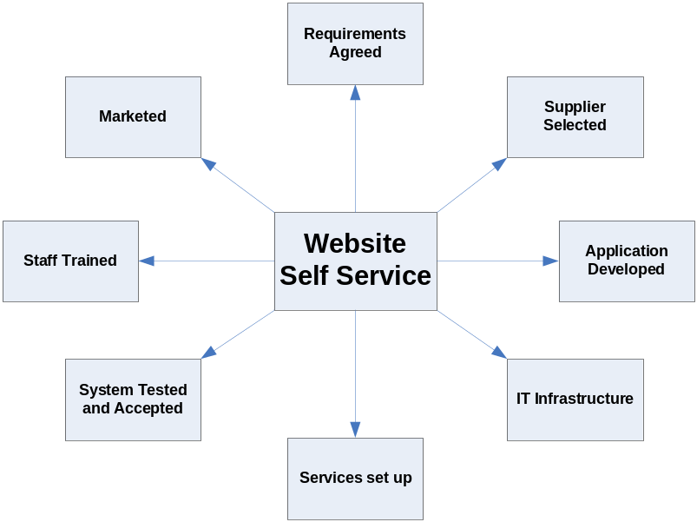

Each product should be assigned as a work package to a relevant owner who is responsible for its delivery. The products should be described in the PID showing:
- What needs to be delivered and any quality requirements
- Owner
- Deadlines
- How the product will be approved and by whom
- When / how often the Project Manager is to be updated on progress

It is important that Product Owners are consulted on the product description prior to them going into the PID being approved.

When products are allocated out to owners the Project Manager’s role becomes more one of commissioning and managing the project rather than carrying out all the work. The approach also stops the project schedule from being an unwieldy list of tasks and instead a high level schedule relating to the products and key milestones.

An example product description is shown below:

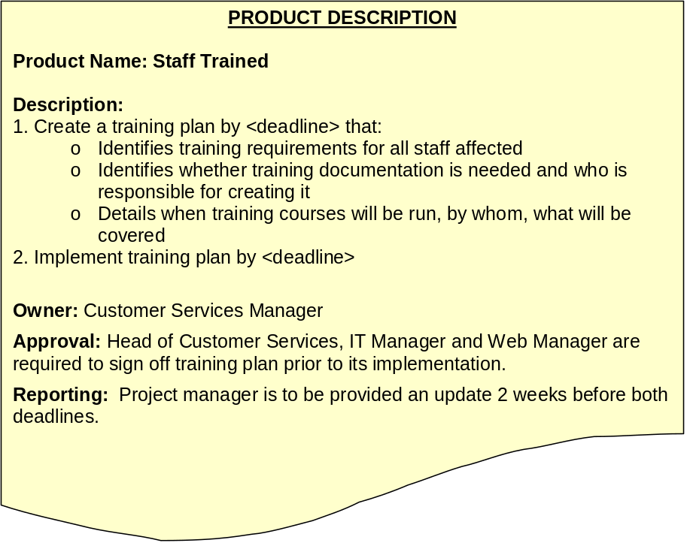

2.2.2 Stakeholder Management
To successfully deliver a project it is critical that you manage your stakeholders. Stakeholders are people who have an interest in your project.

For any project it is important to consider who are the stakeholders? What is their interest in the project? What do they need to know? Do they have any concerns about the project? Do they have ‘buy-in’ to the project?

Having considered the project stakeholders, take a look at the chart below and plot where they currently sit .

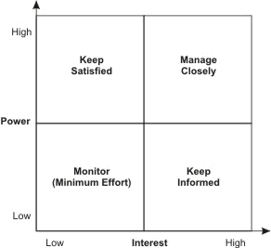

If you are delivering a new system into a department you are going to want staff to be interested and buy-in to it. It is likely the success of the project will be dependent on the department using the system effectively.

If stakeholders are not where you need them to be on the chart above, where do you need them to be? If you have a stakeholder with power but little interest how do you increase their interest? Alternatively if it is a priority to deliver the project and the stakeholder is refusing to engage is there a way of reducing their power e.g. an alternative delivery method or approaching their line manager?

The effort you put into engaging with stakeholders should reflect how important they are to the success of the project. Stakeholders that fall into the bottom left quadrant may just require a general project update through a newsletter, whereas departments directly affected by changes you may which to involve in the design of project solutions.

2.3 Stage 3: Deliver the Project

Once the Project Board have approved the PID the project plans can be implemented.

The Project Manager is responsible for day to day management of the project and ensuring it is operating within the framework detailed in the PID. This will require the use of a project schedule (e.g. Gantt chart) to keep track of progress.

2.3.1 Managing Product Delivery

Where products have been assigned to Product Owners the Project Manager will be responsible for alerting them when they are due to start work on the product.

The Project Manager should define how often they require updates from the Product Owner, what should be included in the update and in what format e.g. verbal, email etc.

Before a product can accepted as completed, the approval criteria defined in the product description must have been fulfilled.

2.3.2 Reporting Progress
Project Managers are required to provide monthly Highlight Reports to the Project Board. At a minimum the Highlight Report should cover:
- Progress against schedule
- Budget position
- Work completed and work coming up
- Risks and Issues

2.3.3 Issues
Issues are problems that arise that mean the project will no longer be able to deliver in line with the terms agreed in the PID. The Project Manager will be responsible for logging and managing Issues using the Issue Register.

As soon as a project is predicted to not deliver in line with the PID / tolerance boundaries, the Project Manager is required to complete an Exception Report and provide it to the Project Board. The Exception report will detail the reasons for the exception along with options and recommendations.

2.3.4 Risks
Risks identified as the project progresses will recorded, tracked, actioned and then closed using the Risk Register.

The risk register will be owned by the Project Manager to ensure that risks are managed as efficiently and effectively as possible. Each project will have its own risk register which will be the responsibility of the relevant Project Manager to maintain and action.

As a minimum, the person raising the risk will provide the following:

- The nature of the risk/issue
- The underlying cause of the risk/issue
- The potential or actual consequences of the risk/issue
- The immediacy of the risk/issue
- In the case of a risk, the likelihood that the risk will materialise.

Potential sources of risk to the project will be allocated a risk score. Each risk will be assessed on its possible impact upon the project within the range 1 to 5, (5 = high impact) and the likelihood of that risk occurring within the range 1 to 5, (5 = high likelihood). The exposure of each risk (exposure = impact x likelihood) will then be calculated.

To ensure a consistent approach to the marking of Risks, the following scheme will be followed:

Risk Score | Impact | Likelihood
5 | Catastrophic | Almost Certain
4 | Major | Likely
3 | Moderate | Possible
2 | Minor | Unlikely
1 | Insignificant | Rare

The exposure will be considered critical if a score of 20+ is calculated. Should this happen, or if there is significant movement upwards on any of the risks listed, a mitigation strategy will be drawn up to accommodate this.

Escalation of risks to Project Board should occur for all above 15 and if there is significant increase in the score but will be at the discretion of the Project Manager.

Within the Risk Register there are 5 possible responses to dealing with a risk:

Avoid : | Change the way you are doing things so no longer exposed to the risk.
Reduce : | Take action to reduce likelihood that risk will occur or reduce the impact if it does
Transfer : | Transfer the risk to someone else e.g. insurers
Accept : | Accept the risk for what it is, but implications must be well understood
Contingency: | In addition to above, plan for what you will do if risk occurs

2.4 Stage 4: Close Project
The Close Project stage ensures that the project has a distinct end point rather than drifting into operational management for the delivered products. The activities of this stage include:

- Reviewing the progress of the project against its PID / Project Brief
- Ensuring that all project deliverables have been completed to the customer’s satisfaction;
- Identifying any outstanding issues (that may need to be followed up);
- Ensuring all documentation is stored on the loop for future reference (e.g. audits);
- Recording and sharing any lessons learned which may help other projects;
- Communicating the closure of the project to all interested parties; and
- Producing the End Project Report.

The End Project report must be accepted by the Project Board before the project can be closed.

3. Document Version Control

All copies of documents/products prior to being approved will carry the status of “draft” and will be numbered Version 0.1, 0.2, 0.n.

The first approved version of a document/product will be numbered version 1.0. Approved versions of all documents/products will require re-approval if any further amendments are required. Versions 1.1, 1.2, 1.n are draft issues prior to the revised document approval, and then it becomes 2.0.

Appendix – Project Templates

Template Page
Agenda 13
Minutes 14
Outline Business Case 15
Project Initiation Document 16
Communication and Engagement Plan 18
Highlight Report 21
Risk Log 22
Issue Log 23
Exception Report 24
Project Closure Report 25


<Project name> PROJECT BOARD
AGENDA

Date: | Time:
Location:
No. | Item | Lead | Attachments
1. | Apologies
2. | Review Minutes and Actions from last meeting
3. | Highlight Report
4. | (Insert other agenda items here)
x. | Risks and issues
y. | A.O.B.

Date of next meeting:
<Project name> Project Board
Minutes

Date: Time:

Location:

Present:

Apologies:

No. | Item
1. | Apologies
2. | Review Minutes and Actions from last meeting
3. | Highlight Report
 | (Insert other agenda items here)
X. | Risks and Issues
Y. | A.O.B

Action List
No. | Action | Owner | Date Raised | Due Date | Status / Completion Date
1.
2.
3.
4.

Outline Business Case Draft v0.1 DD-MMM-YYYY
Project Name |  | Programme |  | 
Project Manager |  | Project Executive
Purpose: To seek approval to commit resources to plan the project in detail.

Executive summary
[This section should highlight the key points of the document and the potential return on investment expected e.g. 3 options have been explored which will reduce customer queries arising from inefficient working practices, provide a purpose built on-line monitoring and booking system, increase satisfaction levels and reduce the number of calls to the planning department. Key benefits to the solution of the problem include saving the Council £8,000 pa].

Reasons
[Describe why the project is needed i.e. business problem being faced or business opportunity which will help to provide efficiencies within the organisation. Within this section you should explain the “opportunity” or “problem” e.g. a problem with inefficient working practices which are causing the Council to lose revenue, reduce customer satisfaction levels or impacts on capacity. You should also link it to the Corporate Objectives and Service Delivery Plan].

Options
[Brief description of the different options considered for the project. Usually there should be 3 options put forward (and there tends to be one which is “do the minimum or do nothing” option)]

Business Benefits Expected
[Expressed in measurable terms and provide stakeholders with an opportunity to make an informed decision regarding the best option. Benefits may include financial, but also skills development, productivity, increased satisfaction levels etc]

Risks
[Summary of the key risks of the project. You may also like to consider the risk of developing the project on the organisation e.g. the computer programmes not being in use whilst upgrades are undertaken which could lead to a reduction in productivity etc]

Cost
[You should include set up costs for delivering the project as well as ongoing costs. If actual costs are not available estimates should be provided (clearly marked as estimates)]

Timescales
[Summary of the Project Plan with corresponding outputs]

Assessment of effectiveness
[You should list the methods by which you are going to assess the effectiveness of the project e.g. stakeholder surveys etc]
Project Initiation Document Draft v0.1 DD-MMM-YYYY
Project Name |  | Programme
Project Manager |  | Project Executive
Purpose: To seek approval to proceed with delivery of the project.

Background
[Provide a description of the background and purpose of the project. Include any history of events and a brief summary of any current system that is to be replaced.]

Business Case
[Describe how this project supports the Corporate Plan, plans or programmes. Describe in simple terms the key benefits of the project. Explain the reasons for the selection of the chosen solutions (where appropriate). Where applicable an Equality Impact Assessment should be carried out and the results included here.]

Project Objectives and Scope

Project Objectives
[Explain what the project needs to achieve in terms of performance and quality, budget and time from conception to completion. Describe what will be in place once the project is completed.]

Project Scope
[Define the scope of the project. Specify inclusions and exclusions. Define any boundaries and/or dependencies with other projects.

Define:
- Any exclusions from the scope
- Constraints on the project (e.g. resource availability)
- Interfaces to other projects and/or systems
- Dependencies on other projects or parts of the business]

Project Deliverables
[Provide a list of the key deliverables (products) of the project. Where possible, indicate the responsibilities for delivering the products (e.g. supplier, user etc), expected timescales and any approval requirements.]

Project Approach
[Explain how the project will be organised in terms of stages and product delivery. Identify any standard process models that are to be used for stages of the project e.g. Prince 2.]

Project Schedule
[Provide an overall schedule for the project. This should at least provide a high-level view of the stages and the timescales e.g.

Product | Jan YY | Feb YY | Mar YY | Apr YY | May YY | Jun YY | Jul YY | Aug YY | Sep YY | Oct YY | Nov YY

Organisation- Roles and responsibilities
[Describe the specific roles and responsibilities].

Communications and engagement
[Describe the project approach to communications and engagement. Identify all interested parties, the types of information they require, the mechanisms and frequency of communications. Include internal project communications and communications to external parties.]

Resource requirements
[Provide an indication of the expected resource requirements for the proposed project]

Project costs
[Provide an outline of the anticipated costs of the project.]

Project quality
[Define any standards or ways of working that need to be met. Identify any quality reviews or audits to be conducted and who will be responsible for conducting them. Define and management processes needed to support the project (e.g. change control).]

Project controls
[Define any controls on the project e.g.
- Tolerance levels
- Reviews
- Management reporting
Specify any project review points during the project process.]

Risk Management
[Briefly set out known risks.]

No. | Risk and Mitigation | Impact  (1-5) | Likelihood  (1-5) | Overall Exposure  (Impact x Likelihood)
1
2

Communication and Engagement Plan Draft v0.1 DD-MMM-YYYY

Project Name |  | Programme
Project Manager |  | Project Executive

Stakeholders and Target Audiences
The table has been part populated for illustrative purposes only

Stakeholder Group | Stakeholder Code | Specific Audience | Why interested? | Current views of Stakeholder Group | Principles of communicating with Stakeholder Group
Sponsors | A | Members (relevant committee) | -Want to ensure service levels remain high  -delivery of improvements set out in business case  - Need to ensure budget is being spent effectively | -Currently positive view of project.  - Important to keep informed and level of interest high | Focus is on ‘big picture’, reassurance on achievements secured and on communicating what decisions committee need to make and why
Sponsors | A | Director (relevant to area)
Users | B | End Users
Users | B | Line Managers / Directors
Staff | C | General Staff
Staff | C | Unions
Internal Partners and Suppliers | D | Project Team
Internal Partners and Suppliers | D | IT Department
Internal Partners and Suppliers | D | Comms Department
External Suppliers | E
Other councils or Partners | F | Other councils

Communication Channels Available

The table below has been populated for illustrative purposes only. Once completed it should outline the variety of communications channels that can be utilised by the project. It also should provide detailed information about which of the above key audiences and stakeholders each one reaches, its frequency, and the estimated length of lead-in time required to plan ahead to use it:

Technique | Audience(s) | When | Lead in time | Contact | When and Why to Use
Project Board meetings | A (Sponsor only), B | Monthly, or as arranged | 5 days | Project manager | Frequently - to check progress, update on new developments and identify upcoming issues.
Highlight Reports for Committee | A | Quarterly | 2 weeks | Sponsor | To update committee on progress, escalate risks and issues.
Project Team Meetings | B) | As arranged | Immediate | Implementation Team Leader | For key staff in department - to check progress, update on new developments and identify upcoming issues.
Seminars and Workshops | B, D, E | As arranged | 3 weeks | Project manager | As appropriate - for specific audience/topics when seeking information and opinions from participants and where they need to be given the opportunity to ask questions
Team Meetings | B, C, D | Monthly | 1 week | Service Leads | To pass out information across Council, could also be used to get feedback.
ECDC Connect | A, B, C, D | Monthly | 2 weeks | Communications service | To inform all staff and Members of key developments / landmarks / successes
Intranet Page | A, B, C, D | Immediate | 2 weeks | Web team | Key messages for Members and Staff.
Phone | A, B, C, D, E, F | Immediate | N/A | Project manager | As appropriate to request information + actions from / inform of activity required of specific audiences
E-mail | A, B, C, D, E, F | Immediate | N/A | Project manager | As appropriate to request information + actions from / inform of activity required
Intranet hyperlinks on auto-signature | A, B, C, D | With every email | N/A | Project manager | On all emails if intranet site is established – to allow staff to access background information.
Presentations | A, B, C, D | As arranged | 2 weeks | Project manager | As appropriate - for specific audience/topics only where detail is needed and participants need to be given the opportunity to ask questions
Manuals | B, D | As produced | 1 month | Project manager | To provide detailed instructions to users
Leaflets | A, B, C, D | As produced | 1 month | Communications service | To provide detailed and agreed instructions/information to users
Posters | A, B, C, D | As produced | 1 month | Comms service | To raise profile of project.
Pay slip messages | A, B, C, D | Monthly | 1 month | Payroll | To communicate simple messages appropriate to all staff.

Communications Action Plan

Date | Action | Owner | Priority (1-3) | Notes
MM YYYY
MM YYYY

Highlight Report DD-MMM-YYYY
Project Name |  | Programme
Project Manager |  | Project Executive
Purpose: To provide a progress update on the project

Period Covered:
Overall Project Status | G
Briefly explain the reasons for assigning the overall project status as red, amber or green as appropriate.
Budget Status | G
Complete the table below and explain the reasons for assigning the budget status. Identify any major items that have been purchased or ordered in the period, and whether there will be significant expenditure in the next period.

Summary of current budget position

Project Budget  £ (1) | Spent to date  £ (2) | Committed to date  £ (3) | Budget less committed spend  £ (1)-(2)-(3)

Schedule Status | G
Explain where the project stands against the project plan and the reasons for assigning red, amber or green.

Work Completed | G
Describe what the project has achieved in the period covered. Focus on what the project has delivered rather that the activities that have taken place.

Reference the products delivered back to the project plan. Identify any products that should have been delivered during the period (according to the plan) but which were not delivered. Explain when these will be delivered.

Risks and Issues | G
Give an outline of any actual problems (these should also appear in the Issues Log) and potential future problems (these should appear in the Risk Register).
Forward Plan | G
What products/outputs/milestones are due between now and the next scheduled Highlight Report? Indicate whether you have a high level of confidence that things will go to plan (Green) or there may be problems delivering to plan (Amber) or you believe there is little chance of achieving what was planned (Red). Be realistic!

Risk Log Updated: DD-MMM-YYYY

Project Name |  | Programme
Project Manager |  | Project Executive

Mitigation Strategies: |  | Risk Score | Impact | Likelihood
Avoid: Change the way you are doing things so no longer exposed to the risk.  Reduce: Take action to reduce likelihood that risk will occur or reduce the impact if it does  Transfer: Transfer the risk to someone else e.g. insurers  Accept: Accept the risk for what it is, but implications must be well understood  Contingency: In addition to above, plan for what you will do if risk occurs |  | 5  4  3  2  1 | Catastrophic  Major  Moderate  Minor  Insignificant | Almost Certain  Likely  Possible  Unlikely  Rare

 |  |  | , | Initial Score |  |  | Latest Score |  |  |  |  |  |  | Actions
Risk Ref No. | Initiated by / date | Description of Risk & Consequences | Risk Cause/Driver | Impact | L'hood | Total | Impact | L'hood | Total | Mitigation Strategy | Contingency Plan | Control Measures | Status (Date) | Action | Due Date | Owner

Issue Log Updated: DD-MMM-YYYY

Project Name |  | Programme
Project Manager |  | Project Executive

Priorities: |  | Disposal -Outcome of final action taken to close issue e.g.
Urgent: Potential to cause exception and close proximity  High: Potential to cause exception  Medium: Manageable within tolerances  Low: Nuisance |  | - requesting/agreeing changing the way things are done  - accepting an "off specification"  - resolving an uncertainty  - raising a risk

 |  | Issue Assessment |  |  |  | Issue Disposal
Risk Ref No. | Initiated by / date | Description of Issue | Consequences/ Impact | Priority | Issue Owner | Action Deadline | Action Owner | Action | Outcome/Disposal | Final Disposal Date

Exception Report DD-MMM-YYYY
Project Name |  | Programme
Project Manager |  | Project Executive
Purpose: To alert Board that project is predicted to no longer deliver in line with agreed PID and to recommend way forward
Background
Briefly provide a description of the background to the exception/deviation and reasons for assigning the overall project status as red, amber or green (as appropriate).
Include any history of events and a brief summary of the current situation.
Describe what caused the exception/deviation and what aspects of the project are/will be affected.
Consequences
Briefly explain what the potential consequences of the exception/deviation are on the project.
Specify how the following aspects of the project (as appropriate) will be affected:
- Business Case
- Project Mandate
- Project Plan (including timescales)
- Key Product Plan
- Project Issues/Risks/Exceptions
- Project Costs
- Project Quality
Available Options
Describe the alternatives available to correct or deal with the exception/deviation and the potential time/cost/quality implication of each option considered.
Recommendations
Provide a recommendation as to which option should be chosen.
Briefly explain the reasons for the selection of the chosen solution.
Outline Exception Plan
If possible create an outline exception plan for the recommended option.

Project Closure Report DD-MMM-YYYY
Project Name |  | Programme
Project Manager |  | Project Executive
Purpose: To present the performance of project against the PID and request project is formally closed

Project Budget Overview (£K)
Budget Description | Original MMM -YY | Revised MMM - YY | Actual MMM - YY | Closing Balances
E.g. consultancy cost, new system
Total Project Costs

Performance against Planned Objectives
Ref. | Objective | Achieved | Comments

Completion Criteria
List the criteria which must be met to confirm that the project is completed. For each criteria listed, assess whether or not it has been achieved to the satisfaction of the customer.
Category Criteria
Objectives | - The project Objectives have been achieved (as defined in the PID)  - All Project objectives have been achieved as defined in PID | y/n
Benefits | - Some/All benefits have been realised (as defined in PID) | y/n
Deliverables | - All deliverables have been completed ( as defined in PID) | y/n

Delivery of Project Products
Ref. | Product | Delivered | Comments

Initial Review of Project Benefits
Ref. | Benefits | Achieved | Comments

Reviews
Type | Date | Scope and Content
Post Project Implementation Review

Outstanding Items
List any outstanding items which still need to be undertaken even though the project has satisfied the above completion criteria. For each item, list actions required to e undertaken and the Owner responsible for undertaking the action.
Item | Action | Owner
Activities | List all activities or tasks which have not yet been completed (as defined in the project Plan)
Risks | List all business risk which have not yet been fully mitigated
Issues | List any current issues which are impacting on the business and have not yet been fully resolved

Open Project Issues
Ref. | Description | Priority | Agreed Action

On-going Risks
Ref. | Description | Priority | Agreed Action

Post Project Tasks
Task | Owners | Notes

On-going support arrangement for any systems

Lesson Learned
What went well? | What didn’t go well? | What can we do better to avoid making the same mistakes?

Any other comments

